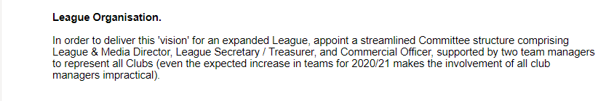
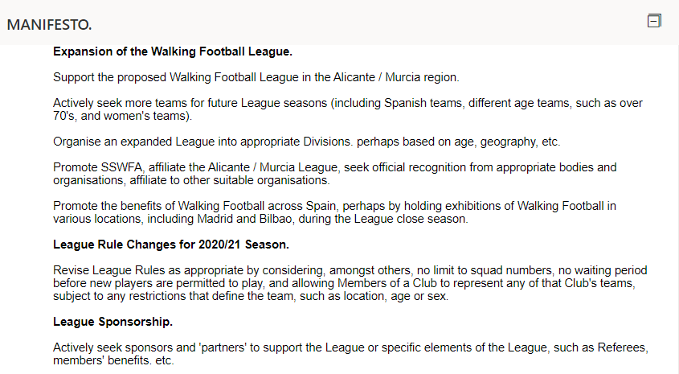
In my Manifesto I have learned from the unexpected which was thrust on us by way of
the Covip virus which closed everything down and ended our first season prematurely.This
caused many problems with fixture cancellations and ultimately the management
committee voted to abandon the league for that season. The League Title was not awarded.

Even now some six months later it is still disrupting our walking football plans having
already forced the cancellation of the start of the new season.

However plans are already being prepared for the start of the new season which in all
probability will be in January.
While like the Club Managers I am very keen for the League to commence,if elected,I will
ensure that before it does start ALL restrictions,precautions and risks will be assessed and
only when it is deemed that there is no more risk than normal in catching the virus will
the season commence.

On occasions during the past season I came in for criticism. Some of it justified, some of
it unjustified most of which always came from the same person.
In any position of being in charge decisions have to be made. Sometimes right sometimes
wrong. When I am wrong I will take the criticism and endeavour not to repeat the same
mistakes. When the criticism is in my opinion unwarranted I will refute it accordingly.

The Post of League Director will have been advertised for 15 days. Applications invited
from any current manager who thinks he has the best qualities,experience and is the best
candidate has had the option to apply as I am doing now.

Thank You for allowing me to present this Manifesto to you and presenting why I
think I am the right person for the job.

My final words are to Thank Steve Lyndon for nominating me and his chosen words
to support the nomination.

Ronnie Waugh

